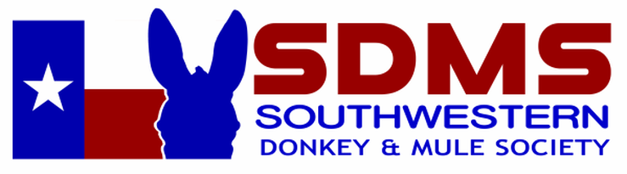
The clASSic DONKEY AND MULE SHOW
2024
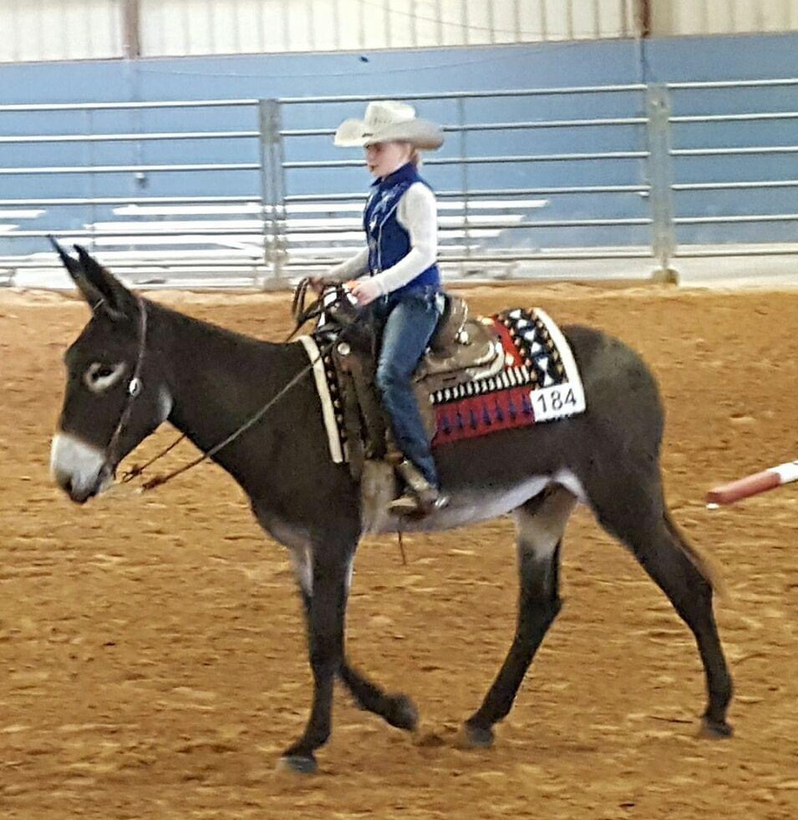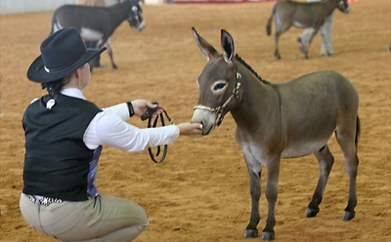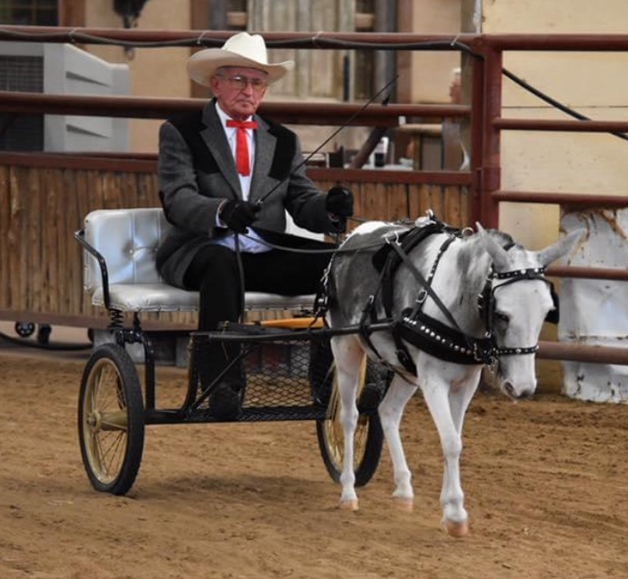
Saturday, May 11th & Sunday, May 12th, 2024
Location:
Legends Horse Ranch, 3018 FM2578, Kaufman, TX 75142
legendsequestriancenter.com
Tel: 903 804-3001
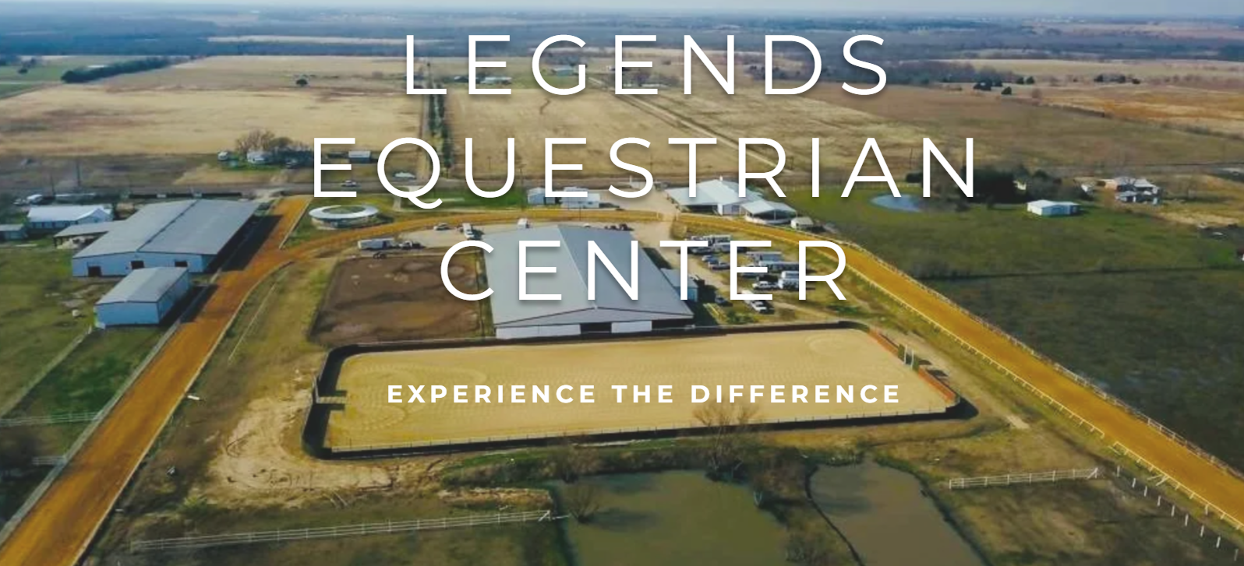

- Special Awards and Ribbons  - Classes in halter, showmanship, western performance, speed events, jumping and driving for adults and youth  - Multiple Divisions for young and older donkeys  - Open to all Donkeys and Mules, (Mammoths/Standards/or Miniatures)  - Nearby hotels:  - Holiday Inn, 300 Tanger Dr. Terrell, TX Tel: 855 797-6733  - Quality Inn & Suites, 103 Mira Pl, Terrell, TX Tel: 972 524-5590  - Days Inn by Wyndham, 1618 TX-34, Terrell, TX Tel: 972 551-1170  - Bestway Inn, 200 US-175, Kaufman, TX Tel: 972 544-0471 | - Class lists, Entry Forms and Membership form available at: https://www.swdonkeyandmulesociety.com/  - Entry deadline April 20, 2023 (no late entries)  - Stall Fee $35  - RV Hookups $45  - Concessions  - Sanctioned by  - NMDA (confirmed)  - ACOSA (confirmed)  - Incentives for new members/first time entries
For further information please email: SDMS@mail.com

