Calling all 14-18 year old
Donkey & Mule competitors at the
2024 Ft. Worth Stock Show and Rodeo!
Do you want to earn a $2000 scholarship??
Review entry requirements at:
swdonkeyandmulesociety.com
Click on the Ft. Worth Scholarship Tab

This scholarship contest is sponsored by:
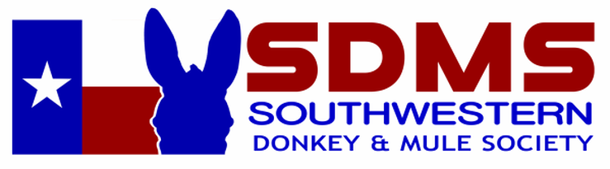
& The Fort Worth Stock Show and Rodeo

