SDMS

Southwestern donkey & Mule Society newsletter
  - December Issue 2018
December 8, 2018

Year End Awards Banquet
&
Elections of Officers

11:00 a.m.
Heitmiller Steakhouse & BBQ
4509 I-35 at loop 340, Waco TX

Year End Points are available online at

www.swdonkeyandmulesociety.com

Please bring an unwrapped gift for the Auction

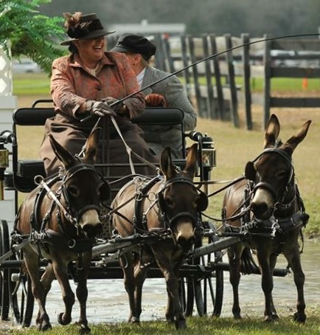
Sally Armstrong
It’s A Wrap!
This has been a phenomenal year. SDMS membership is at an all-time high and the competition bar continues to be raised. Bobbie Ferraro and her Miniature Donkey, Peace Pipe Indian Scout won the Coon Jumping Event at the FWSSR, and they continue to hold the record in the Miniature Donkey Category.
FWSSR was a great place to introduce many visitors to our gentle, smart athletes and their handlers. Spectators roamed the hall of the stalls to meet and pet donkeys and mules along the way.
The SDMS ClASSic was held in a brand new, air-conditioned facility in Belton, Texas. The Bell County Livestock Complex is first class. Greg Schlosser and Vicki Taylor made the morning news on KCEN, and what a treat to see Vicki driving her team at the show.
Our Belton Spooktacular was a great end to our show season. The costume contest is always a favorite. For those there, they will never forget this year’s 1st place costume. For those not there, just ask Greg Schlosser, he will recall.
Unfortunately, weather prohibited our Longears Festival in November this year. It’s always a fun event and a chance to spend time without the pressure of showing.
It’s hard to believe we are about to turn another year older. SDMS was formed in 1973, so 2018 makes our club officially 45 years old. We have 104 household members, including five Lifetime Members. Some might remember Lifetime Member Sandra Osborne-Neeley. She recently contacted us and was kind enough to write something about her show years. To read her own story, click on the link: Memories by Sandra Osborne-Neeley

Mark Your Calendars
Our Awards Banquet & Election of Officers is this Saturday, December 8th. We have several positions open for the 2019-2020 term. Please consider running for any office or nominating someone you know. Contact Shirley Knott to get your name on the ballot.
Looking Ahead
The Fort Worth Stock Show & Rodeo is January 27 & 27, 2019. The Premium Book was mailed out, and your entries should have been postdated by November 15, 2018. Late Entries are being accepted until December 30, 2018. You can find the information on our website, or contact our treasurer Shirley Knott. This kicks off our 2019 Show Schedule. Look for our SDMS ClASSic July 19, 20, and 21st, and Belton Spooktacular in October.

2019 Membership Renewal
Membership Renewal forms can be downloaded from our website
www.swdonkeyandmulesociety.com
The fees are still only $25 annually. You can also renew at the Awards Banquet on December 8th. Please take the time to fill out the renewal form to insure we have your current information. Don’t miss out on Newsletters, Show Information and updates. We unfortunately do not have an online renewal system at this time.
“SDMS was formed in 1973 for the purpose of promoting family activities and furthering the development of donkeys and mules in the southwestern United States”

Hear Ye’ Hear Ye
So much of our communication is now through emails, Facebook, and our Website. Newsletters are now sent using email. Show notices and important updates are also sent through email. For those on Facebook, reminders and upcoming events are often posted. Facebook continues to reach an average of around 700 people online (300-1100) . Please share your pictures and comments.

Congratulations to our Year End High Point Winner
The Year End High Point Summary and all points are posted on our website. Congratulations to all that participated at the FWSSR, ClASSic, and Spooktacular. We hope to see you at the Awards Banquet. Job well done! We also want to recognize members Kim Winton and Jim Speck for winning NMDA Year End High Point Jack, Jennet and Gelding. Congratulations! What an accomplishment.

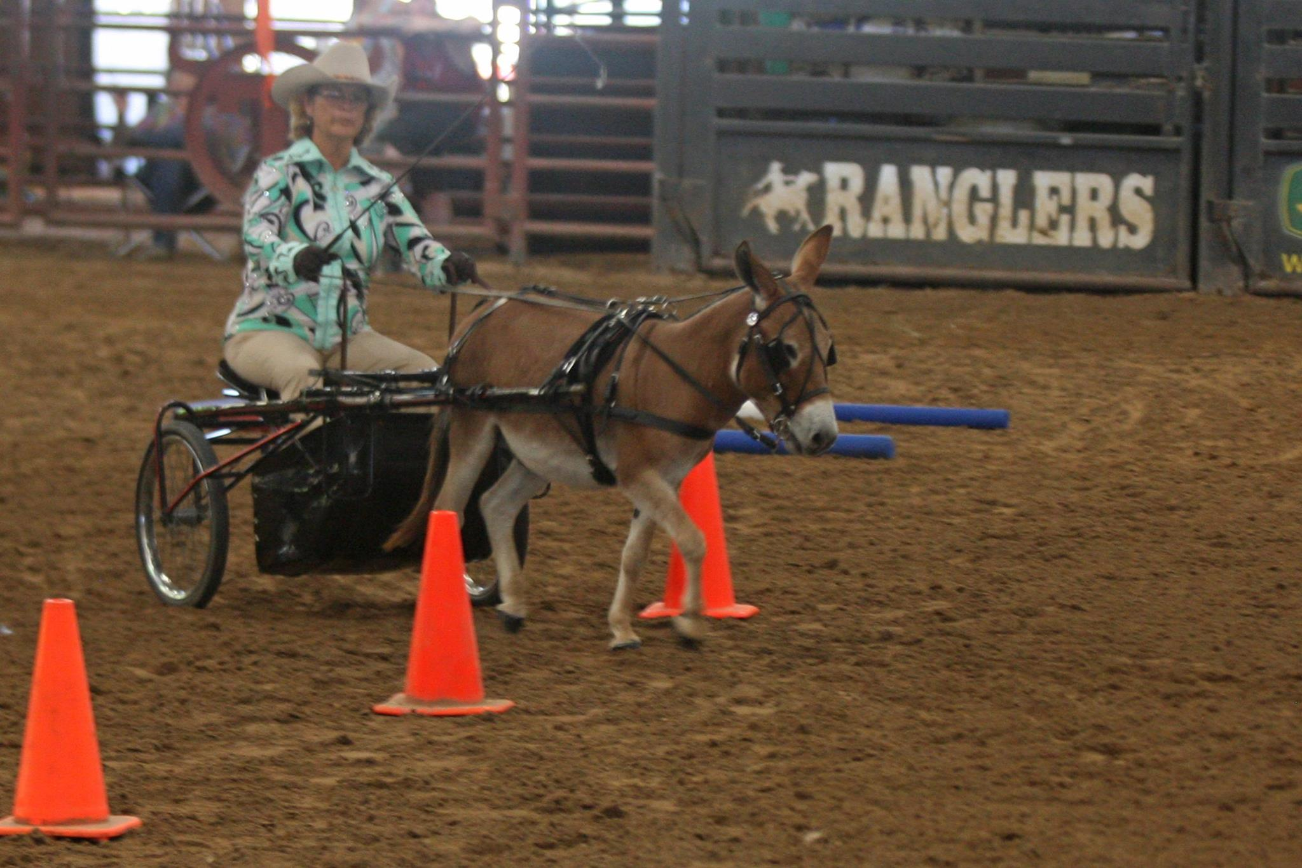
Sandi Costa

New Rule Books
Every two years we ask for your suggestions regarding rule changes you would like to see for SDMS. After the Rules Committee approves any changes, we print the new books for our members and distribute them at the Annual Meeting. The latest rule book will be posted on our website soon. Thank you Sarah Matz for making those changes and formatting the new rule book.

Elections for 2019-2020
There are several positions open for the upcoming term. The discription of each position is on our website. Please consider running for office. We have been very fortunate to have Lynda Cornell as Show Chairperson. This position is open for 2019-2020 as Lynda is leaving this position to pursue other interests. Please read Lynda’s note by clicking on the link. Lynda’s Thank You.

And Finally
I would like to thank everyone who has supported SDMS through their continued membership, donations, volunteering, sponsorship, articles, time, friendship, and expertise. Thank you for sharing your time and talent with our Youth and newer exhibitors. They are our future.
I will not be running for the position of secretary. I’ll be seeing you at the shows. It has been a pleasure keeping in touch with you, and serving on the board of SDMS. Merry Christmas!

Donna Wallace Baethge
2017-2018 Secretary SDMS

