Southwestern Donkey & Mule Society
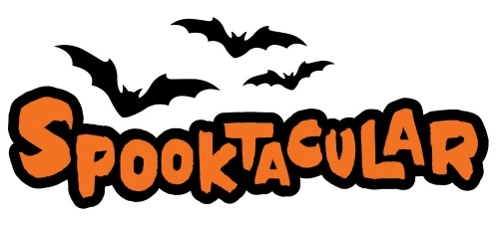
Show

Donkey & Mule Show
October 29 & 30, 2022
**Entry Deadline (Postmarked): October 15, 2022**

Bar 17 Ranch
2384 CR 2315, Lampasas, TX 76550
(512) 578-6889
Hosted & Sanctioned by the Southwestern Donkey & Mule Society
www.swdonkeyandmulesociety.com

Show Judge: Ruth Graves

NMDA Sanctioned-ALL MINIATURE DONKEYS MUST BE REGISTERED

- Great facility
- Kitchen available with ice, stove, plug-ins, and microwave
- Showers available on site
- Coffee and Donuts available on Saturday & Sunday
- Silent Auction both days (Bring items & bid often)
- Costume Class open to all animals Saturday Afternoon
- All High Point & Reserve High Point Awards will be cash!

Host Hotel: Quality Inn and Suites
1200 Central Texas Expressway, Lampasas, TX 76552
512-556-9292
Room Block is good through Oct. 1, 2022
Room Block Name: Bar 17

