Southwestern Donkey & Mule Society
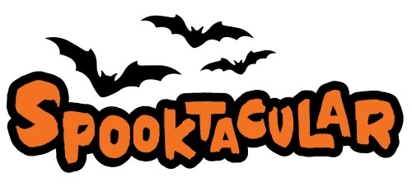
Show

Donkey & Mule Show
October 28, 2023
**Entry Deadline (Postmarked): September 30, 2023
No Late Entries

Bar 17 Ranch
2384 CR 2315, Lampasas, TX 76550
(512) 578-6889
Hosted & Sanctioned by the Southwestern Donkey & Mule Society
www.swdonkeyandmulesociety.com

Show Judge: Karen Doby

- Great facility
- Kitchen available with ice, stove, plug-ins, and microwave
- Showers available on site
- Coffee and Donuts available on Saturday
- Silent Auction (Bring items & bid often)
- Lunch will be provided by Janet Vance on Saturday
- Costume Class & Potato Race open to all animals
- All High Point & Reserve High Point Awards will be cash!

Host Hotel: Quality Inn and Suites
1200 Central Texas Expressway, Lampasas, TX 76552
512-556-9292
Mention Mule & Donkey Show for a discount

