Southwestern Donkey & Mule Society presents:
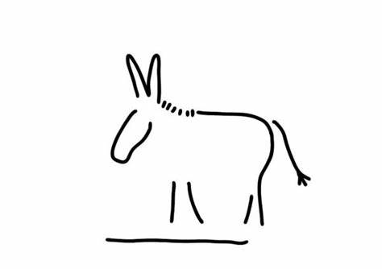
Mule & Donkey Show
May 13 & 14, 2023
**Entry Deadline (Postmarked): May 1, 2023**
Bar 17 Ranch
2384 CR 2315, Lampasas, TX 76550
(512) 578-6889
Hosted & Sanctioned by the Southwestern Donkey & Mule Society
www.swdonkeyandmulesociety.com

Show Judge: Karen Doby

NMDA Sanctioned-ALL MINIATURE DONKEYS MUST BE REGISTERED

- Great facility
- Kitchen available with ice, stove, plug-ins, and microwave
- Showers available on site
- Coffee and Donuts available on Saturday & Sunday
- Silent Auction both days (Bring items & bid often)
- Frito Pie Lunch provided on Saturday
- Division High Point and Reserve High Point Awards

Host Hotel: Quality Inn and Suites
1200 Central Texas Expressway, Lampasas, TX 76552
512-556-9292
Mention Mule & Donkey Show for a discount

