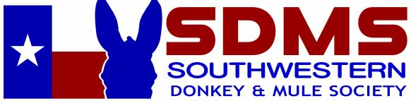

2023 Southwestern Donkey and Mule Society Youth Scholarship Contest
To be completed and mailed with a postmark of December 15, 2022, to
SDMS % Julie Archer P.O. Box 1013, Krum, TX 76249

ELIGIBILITY
- This contest in open to all youth 18 years old and younger as of January 1, 2023.
- The youth must compete in a minimum of 4 classes in any of the offered youth classes. (Classes can be all in one division, or a combination of mule, donkey, miniature mule, or miniature donkey classes.) Placings will not be considered when selecting the winner.
- A completed application and personal essay should be submitted by Dec. 15, 2022.
INSTRUCTIONS FOR APPLICATION
- Enter classes in the Fort Worth Stock Show Mule and Donkey Show. (There are no youth class entry fees.) These classes will be entered through the Fort Worth Stock Show office.
- Fill out the application provided.
- Write a minimum one-page personal essay covering the following topics:
  - Introduction of who you are-name, grade, where you live, what makes you special, etc. Tell the judges who you are.
  - What clubs or activities you are involved in?
  - What is your involvement concerning mules/donkeys/mini mules/mini donkeys?
  - Describe something you find interesting about mules/donkeys.
- Mail the application and personal essay with a post mark date of December 15, 2022, to P.O. Box 1013, Krum, TX 76249.
CONTEST PORTION HELD AT THE FORT WORTH STOCK SHOW DURING THE SHOW
- Participation in a minimum of 4 classes in the mule/donkey/mini mule/mini donkey.
- The participant will prepare an oral presentation over anything related to mules and donkeys.
  - 3-5 minutes long
  - Include a poster board or other visual aids that relate to the topic you are presenting
  - At the conclusion of the presentation, questions will be asked, and the personal interview will be conducted
- A written exam will be given that will cover identifying parts of tack (i.e. saddles, harness, carts), identifying anatomy on mules and donkeys, & breed identification.

SCHOLARSHIP SELECTION
One winner will be selected and awarded a $500.00 scholarship. This scholarship will be presented at the conclusion of the show at the awards ceremony. The judges’ decisions concerning this scholarship are final.
- Participation in a minimum of 4 classes is required but placing are not considered when selecting the scholarship recipient.
- The personal essay will count for 25% of the score.
- The oral presentation will count for 25% of the score.
- The personal interview will count for 25% of the score.
- The written exam will count for 25% of the score.
SCHOLARSHIP DISBURSEMENT
The scholarship will be disbursed through the Fort Worth Stock Show once the youth has finished high school and is entering a university or trade school.

