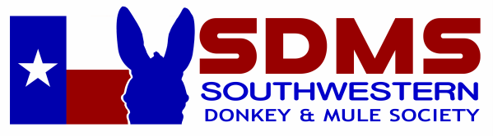

Southwestern Donkey and Mule Society is a 501(c)(5) nonprofit organization under section 170(c) of the IRS code.
Please consider sponsoring a class, or make a donation to be applied toward our next show.

Platinum Sponsor $1,000 and above $ _______________
Gold Sponsor $500 - $999 $ _______________
Silver Sponsor $300 - $499 $ _______________
Champion High Point Sponsor $100 $ _______________
Reserve Champion High Point Sponsor $75 $ _______________
Individual Class Sponsor $25 per class $ _______________
Total Sponsorship $ _______________

List Awards or Classes to Sponsor
__________________________________________ ________________________________________
__________________________________________ ________________________________________
__________________________________________ ________________________________________
(If your choice is already sponsored we will select another class for you. Your sponsorship will be applied to our upcoming show unless a particular show is designated. Many thanks!)

Sponsors Name, Business Name & Address as you would like it to appear:

Business Name ______________________________________________________________________
Individual Name ______________________________________________________________________
Address ____________________________________________________________________________
City __________________________________________ State ______________ Zip ______________
Phone _____________________________ Email __________________________________________
Website ____________________________________________________________________________

Please mail to: Shirley Knott (SDMS Treasurer) P.O Box 869. Collinsville, TX 76233

