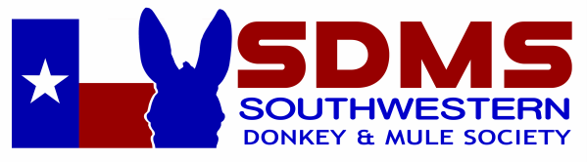

Southwestern Donkey and Mule Society is a 501(c)(5) nonprofit organization under section 170(c) of the IRS code.
Please consider sponsoring a class or make a donation to be applied toward our next show.

Platinum Sponsor $1,000 and above $ _______________
Gold Sponsor $500 - $999 $ _______________
Silver Sponsor $300 - $499 $ _______________
Champion High Point Sponsor $100 $ _______________
Reserve High Point Sponsor $75 $ _______________
Individual Class Sponsor $25 per class $ _______________

Total: $ _______________

List Awards or Classes to Sponsor
__________________________________________ ________________________________________
__________________________________________ ________________________________________
__________________________________________ ________________________________________
(If your choice is already sponsored we will select another class for you. Your sponsorship will be applied to our upcoming show unless another show is designated. Many thanks!)

Sponsors Name, Business Name & Address as you would like it to appear:

Business Name ______________________________________________________________________
Individual Name ______________________________________________________________________
Address ____________________________________________________________________________
City __________________________________________ State ______________ Zip ______________
Phone _____________________________ Email __________________________________________
Website ____________________________________________________________________________

Please mail to: Mary Stewart (SDMS Treasurer) 1790 Bell Springs Road, Dripping Springs, TX 78620

